‘AHC 2020 & Horti ASIA 2020 bridge science and commerce’

The 3rd Asian Horticultural Congress (AHC 2020) to be held in Bangkok in parallel with
Horti ASIA 2020 hosted by the International Society for Horticultural Science (ISHS) and the Horticultural Science Society of Thailand (HSST), and co-hosted by VNU Exhibitions Asia Pacific

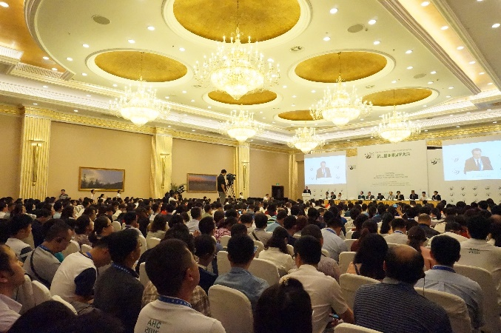

In 2020, the Asian Horticultural Congress (AHC), driven by leading horticultural science societies in Asia, will be back again after its last congress in the People’s Republic of China in 2016. Organized by the International Society for Horticultural Science (ISHS), and the Horticultural Science Society of Thailand (HSST), the AHC 2020 will provide a forum that allows you to keep pace with the latest knowledge and innovations in horticultural science and related industries. Horti ASIA organizers - DLG and VNU Exhibitions Asia Pacific will be co-hosting the congress at the heart of the trade fair and international conferences.

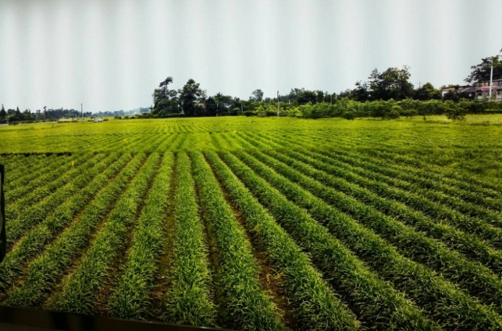
An important milestone will be reached in supporting the Asian horticulture industry with the core drivers of growth. Asian countries have become a strategic focus for horticulture technology as the region transforms from being a trade hub into a knowledge hub, creating and inventing new solutions. Many research & development-based companies are operating; universities and governments in Asia welcome hundreds of researchers, professors, young scientists, horticulturalists from across Asia and beyond. Horti ASIA will be bridging science and practice to enable growers to find better, more practical, solutions.

Asian economies are accelerating with ⅔ of world’s population living in Asia and many challenges lie ahead. Today’s Asian economies are building a sustainable future while respecting the UN global challenges and following the ambition to become the world’s food basket.

Jozef Van Assche - Executive Director, International Society for Horticultural Science said that
‘Never in the course of history have vegetables and fruits been more important in our daily diet. Flowers and ornamental plants add to the quality of our life and environment. AHC 2020 will address the particular needs of Asia and its growing and diversifying population. The joint organization of the 3rd Asian Horticulture Congress and Horti ASIA 2020 will bridge science and industry and will bring our profession to the forefront of this year’s events. Let us ‘join forces and build success’.

Ananta Dalodom – President, Horticultural Science Society of Thailand said that
“AHC 2020 will be a platform aimed at sharing recent research and development findings and innovation in various fields of horticulture and creating a network of technical cooperation among Asian horticulturists and relevant parties, which will be included in a two-day scientific program. In addition, a one-day professional excursion will be arranged for the participants to visit various horticultural production areas and industries. The participants can attend Horti ASIA 2020, the international tradeshow for horticultural and floricultural production and processing technology, which will take place in parallel with AHC 2020.

Researchers, professors, students, government agencies, associations, growers, entrepreneurs and other professionals with an interest in horticulture are cordially welcome to AHC 2020. You will not only meet your friends in the horticultural sphere, but will also experience the hospitality of the Thai people in the land of smiles.”

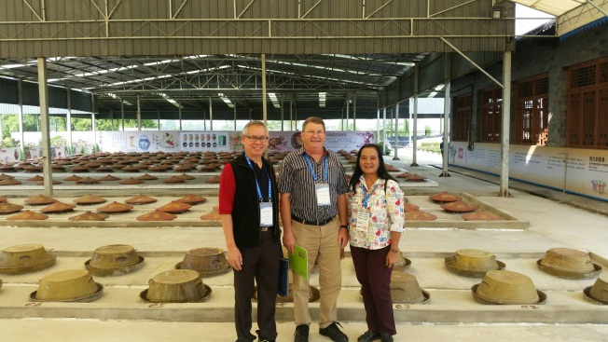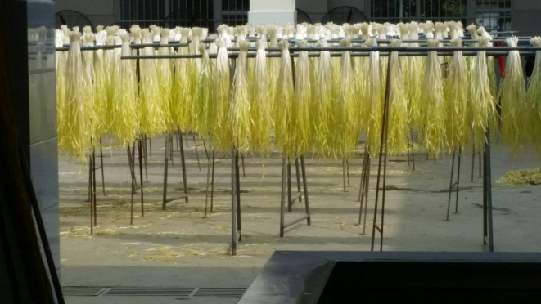

"Knowledge is at the core of it all in today’s horticulture industry. Day to day, it drives companies’ R&D forward. Horti ASIA and AGRITECHNICA ASIA warmly welcome the AHC. It is scientific discovery that inspires visionaries and enthusiasts to create solutions for the markets here. We are all dedicated to meet the UN global food challenges.”

Manuel Madani – Project Manager, Horti ASIA said that “Today the industry drives on newly developed solutions by growing crops smarter. The foundation of this is science and access to information. Horti ASIA aims to be a knowledge source for many farmers and growers who learn from one another.

This is something that has developed recently at Horti ASIA. It’s a shift in mindset by sharing a common vision. Whether you are growers, traders, breeders, logistics providers or food processors, we are all part of it. We believe that sharing knowledge accelerates farmer’s yield and eventually growth.
Key challenges that lie ahead are food safety, water efficiency, post-harvest and cold chain, and making horticultural quality consistent. When we achieve an increase in product quality, Southeast Asia will become more competitive. Today’s access to advanced technologies, the greater demand for fresh produce as a result of dietary changes, seed breeding development, reverse engineered from demand, and biological crop protection are driving the food chain.

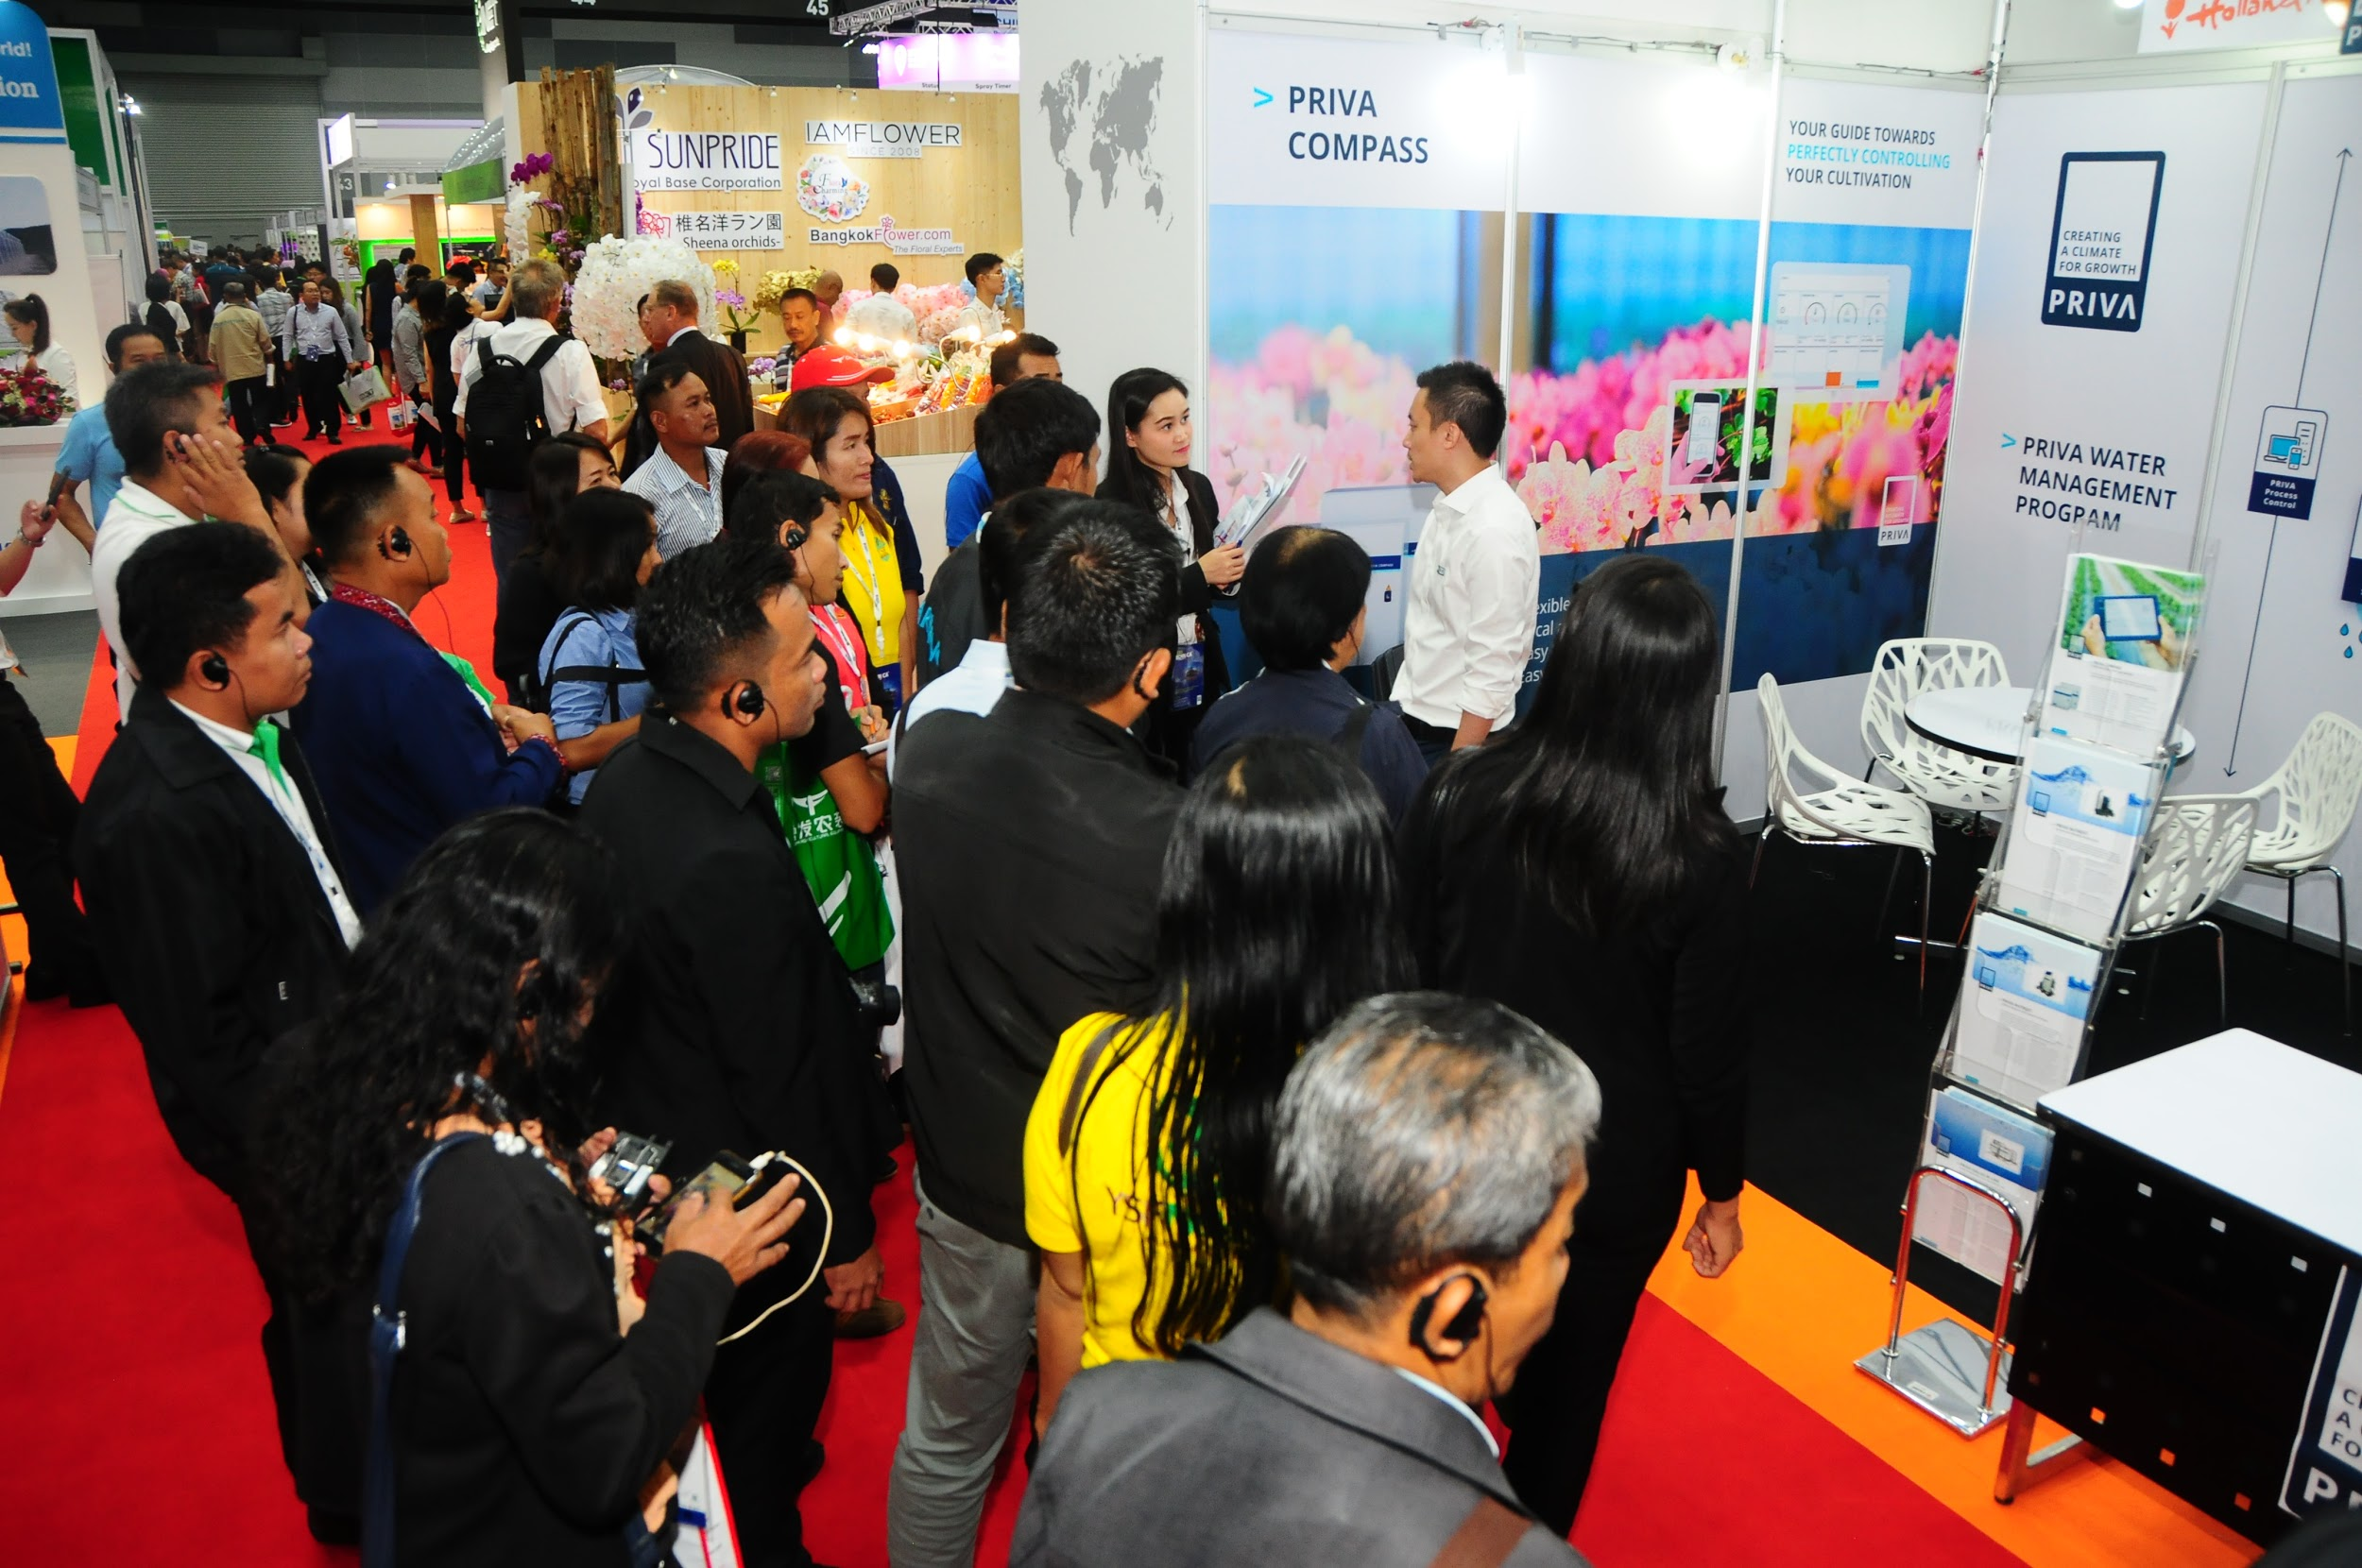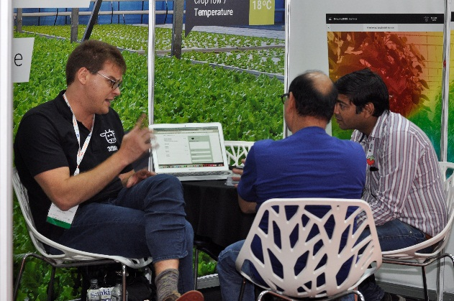

We are all very pleased to be launching the partnerships with the Asian Horticultural Congress and Horti ASIA 2020, a proven regional hub for horticultural technology. Many solutions in regard to greenhouse technology and urban and organic farming have drawn almost 11.000 trade visitors and 829 top visionaries from across Asia. In 2020, we expect further growth in the number of participating countries like Pakistan, India, Sri Lanka and the Philippines.”

The 3rd Asian Horticultural Congress (AHC 2020) will take place from 7 to 9 May in Bangkok Thailand in parallel with Horti ASIA 2020. The objectives are to provide a platform for horticulturists, researchers, young scientists, entrepreneurs and those connected with horticulture and its related industries to share their R&D and innovation; to showcase Thailand’s horticulture at an international level; to create a network of technical cooperation among Asian horticultural researchers, and to enhance trading in the Asian region by promoting economic and social cooperation, culture and tourism both domestically and internationally.

For AHC 2020 secretariat, please contact Mrs. Sunisa Boonyapatipark Email: sueboonya@hotmail.com, ahc2020bangkok@gmail.com

For conference registration, please contact: Ms.Yaowalak Somboonlertsiri | Tel. +662 6700900 Ext.205
Email: yaowalak.som@vnuexhibitionsap.com | www.horti-asia.com
For media relations, please contact: Mrs.Saengtip Techapatiphandee | Tel. +662 6700900 Ext.122
Email: saengtip.won@vnuexhibitionsap.com | www.horti-asia.com

For more information, please contact: Mr. Manuel Madani l Tel. +662 6700900 Ext. 212

