VIV Virtual Summit - Asia Edition -
21-23 April 2021

The Digital Series of cutting-edge Webinars for the Animal Protein Production Value Chain and Connected Industries in Asia.

VIV Virtual Summit – Asia Edition – a selected series of digital webinars from 21-23 April 2021 that includes 30+ virtual keynotes speakers from leading companies and associations in the animal protein production industry. More than 9 high-end Webinars over 3 days, on a dedicated online platform.

Save The Date and Reserve Your Seat in the interested webinars now!
21-23 April 2021| Online platform (Free of Charge)

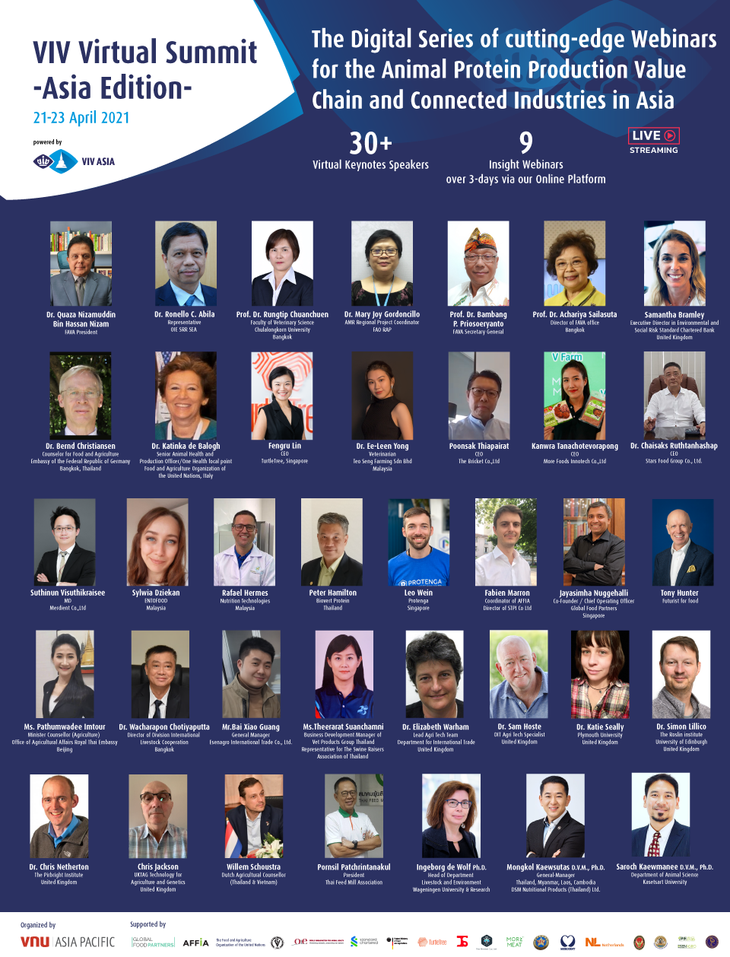
Conference Highlights | Register link!

APRIL 21, 2021

Genetic Futures – Productivity, Animal Health and Clean Growth
Organized by: British Embassy

Time: 10:00 AM Bangkok | 05:00 AM CET) | Register Now

AMR Mitigation in Asia and Farm Biosecurity: 2021 and Beyond
Organized by: FAVA, FAO & OIE

Time: 02:00 PM Bangkok | 09:00 AM CET | Register Now

APRIL 22, 2021

Opportunities for Thai Pork Export to China
Organized by: Department of Livestock Development / The Swine Raisers Association of Thailand / Vet Products China
Time: 09:00 AM Bangkok | 04:00 AM CET| Register Now

Tools & Initiatives to Strengthen Cage-free Egg Production in Asia
Organized by: Global Food Partner
Time: 11:30 AM Bangkok | 06:30 AM CET | Register Now

Are Alternative Proteins the Future of Meat in Asia?
Organized by: Futurist for Food
Time: 01:00 PM Bangkok | 08:00 AM CET | Register Now

Insect Protein in Animal Feed Industry: Exploring Opportunities of Novel Ingredients from Oil to Protein
Organized by: AFFIA
Time: 02:00 PM Bangkok | 09:00 AM CET | Register Now

Resilience of Sustainable Livestock Value Chain Amid Alternative Protein Sources, Climate Change and Post COVID-19
Organized by: Netherlands Embassy in Bangkok
Time: 05:00 PM Bangkok | 12:00 PM CET | Register Now
APRIL 23, 2021

Generation Distancing
Organized by: VNU Asia Pacific
Time: 10:00 AM Bangkok | 05:00 AM CET | Register Now

Women in Agriculture: Leadership, Innovation and Challenges in Asia
Organized by: Standard Chartered / German Embassy / FAO/ Turtle Tree Labs / Teo Seng Capital Berhad / VNU Asia Pacific
Time: 03:00 PM Bangkok | 10:00 AM CET | Register Now
The VIV Virtual Summit – Asia Edition is aimed at providing an interactive platform to allow for exchange of ideas, updates, knowledge, and market trends spread over a span of 3 days. It will touch a plethora of topics, with a focus on Asia – biosecurity in poultry farming, opportunities in Thai pork import to China, recent applications & functionalities for poultry, aqua & swine, transition to cage-free production systems, sustainable productivity, steps to curb the spread of animal diseases & AMR, future of protein consumption in Asia, development of the insect farming industry, just to name a few.

Among the 30+ speakers, you will hear from: Dr Quaza Nizamuddin Bin Hassan Nizam, FAVA Preseident, Jayasimha Nuggehalli, Co-founder & COO Global Food Partners, Dr Bernd Christiansen, Counselor for Food and Agriculture, Embassy of the Federal Republic of Germany Bangkok, Thailand.

Join the exclusive sessions to explore various perspectives and cutting-edge research and development for the topics of your choice.

For more information, please visit https://vivasia.nl/viv-virtual-summit/ or call +662 111 6611 (VNU Asia Pacific, Bangkok Office)

####

About VNU Asia Pacific
VNU Asia Pacific is part of VNU Group, a globally operating exhibition company with offices in Utrecht, Shanghai, Bangkok and consolidates the international exhibition business of Royal Dutch Jaarbeurs. In Southeast Asia, Jaarbeurs formed a Joint Venture with TCC Group, a leading corporate conglomerate in the fast-growing region. From its business hub located in Bangkok, VNU Asia Pacific covers all key exhibition markets in South East Asia. VNU Asia Pacific has a constantly expanding portfolio with currently 19 trade shows and event formats both online and face-to-face platforms including brands from the AgriTech, Animal Husbandry, Animal Companion, Food, Life Sciences, Biotechnology, 5G and IoT and Disaster Resilience industries. For more information, visit www.vnuasiapacific.com

