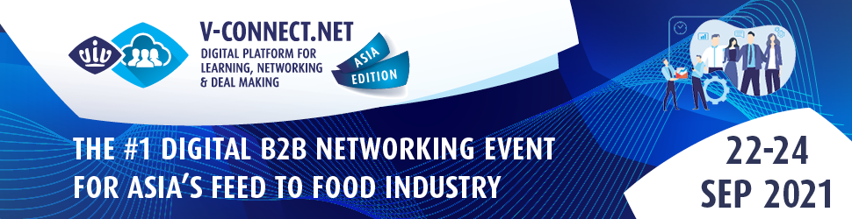

PRESS RELEASE – VIV WORLDWIDE [ Bangkok, Thailand, 13.9.2021 ]

The unparalleled Digital Event for Business Growth in Animal Protein Production is taking off 22-24 September 2021
Learn, network & make deals at V-Connect Asia Edition. Join for free now.

Every professional along the feed-to-food value chain can unlock substantial business growth by attending this 3-day B2B digital event by VIV worldwide. V-Connect Asia Edition takes place 22-24 September, providing the industry with top relevant industry updates and a convenient networking opportunity despite travel limitations in Asia.

Visitors will enjoy the exclusive chance to meet online with 300+ exhibiting profiles presenting their latest products and solutions, and attend 20+ informative professional content sessions by high-level international speakers and influencers across the livestock network. The newly designed V-Connect.net platform will receive all attendees in a single digital space accessible with just a few clicks upon free event registration at www.v-connect.net/asia-edition.

Exciting online Conference Program with 20+ high-level sessions to gain valuable knowledge

What is the future of alternative proteins in Asia? And the region’s next evolution in insect-based ingredients for livestock and aquaculture? What are the latest developments in animal health & nutrition, feed, micro-ingredients and additive management? How is farm production embracing cage-free solutions in Asia? And what are the new, advanced technologies for sustainable future food production?

These topics and many more will be covered by 40+ international experts invited to share their knowledge and updates at the V-Connect Asia Edition event. Moreover, insightful market trends and regulations will be disclosed through dedicated sessions such as: Asian Veterinarians’ AMR Action Plan by FAO-FAVA-PVMA-JVMA-VNU, and Sustainable From Feed To Food: Keeping Up in A Greening World co-organized by the British Embassy.

Inspiring technical sessions on smart farming and optimized solutions in poultry systems, including the women empowering series focusing on Thai women leaders, are further highlights of the rich content program on offer by V-Connect Asia Edition suppliers and partners. The complete sessions overview is available on www.v-connect.net/asia-edition.

Discuss business Deals with feed to food Global Suppliers

With V-Connect Asia Edition, participants will be able to easily interact with 300+ exhibiting profiles from over 40 countries. These suppliers represent every industry sector across animal husbandry and livestock production including feed & feed processing, feed ingredients & additives, animal health & pharmaceutical products, breeding & hatching, farm production, slaughtering/processing/food engineering and logistics/handling/packaging/refrigeration solutions.

Market leaders contributing to this event as sponsors include CJ BIO APAC CO., LTD., Munters Company Ltd., Bioproton Pty Ltd, CHORE-TIME, Alltech, United Ivory Sdn.Bhd., Atacama Bio Natural Products S.A., DACS A/S, Ceva Animal Health Asia and Ceva Ecat-iD Campus. Their product highlights are available on the event website, as is the registration link for getting in touch with them and many more suppliers.

The V-Connect platform breaks new ground with AI-powered matchmaking to guide all attendees to meet with relevant exhibitors. Intuitive search filters can be used to select suppliers and embark on new ventures. Moreover, real-time engagement features such as 1:1 meetings or group meetings in virtual lounges, and voice/video call in-system functions will transform this online event experience into a pleasant and fruitful business journey.

The VIV worldwide network in Asia is gathering online. Don’t miss out.

In preparation for this #1 Digital B2B networking event for Asia’s feed-to-food industry, V-Connect’s organizing team is working with around 100 top Asian regional partners of the VIV Asia established network, inviting valuable profiles to attend and engage in business. V-Connect works with association, conference and media partners to ensure a vast collaboration between global and regional players.

As a result, top suppliers, Asian buyers and livestock experts are now on V-Connect preparing for 3 days filled with learning, networking and deal-making business opportunities. If you haven’t yet created your free online profile, you can do so now. Register via www.databadge.net/viva2021/reg, log into the system, add your profile details and preferences, request meetings and book sessions. Meet the industry online!

VIV worldwide and its partners look forward to welcoming you from 22-24 September for this incredible business opportunity on V-Connect Asia Edition. Strike new partnerships, engage new audiences and cultivate future profitability across Asia and the world. Discover more and begin your journey today. For more information, visit www.v-connect.net/asia-edition.

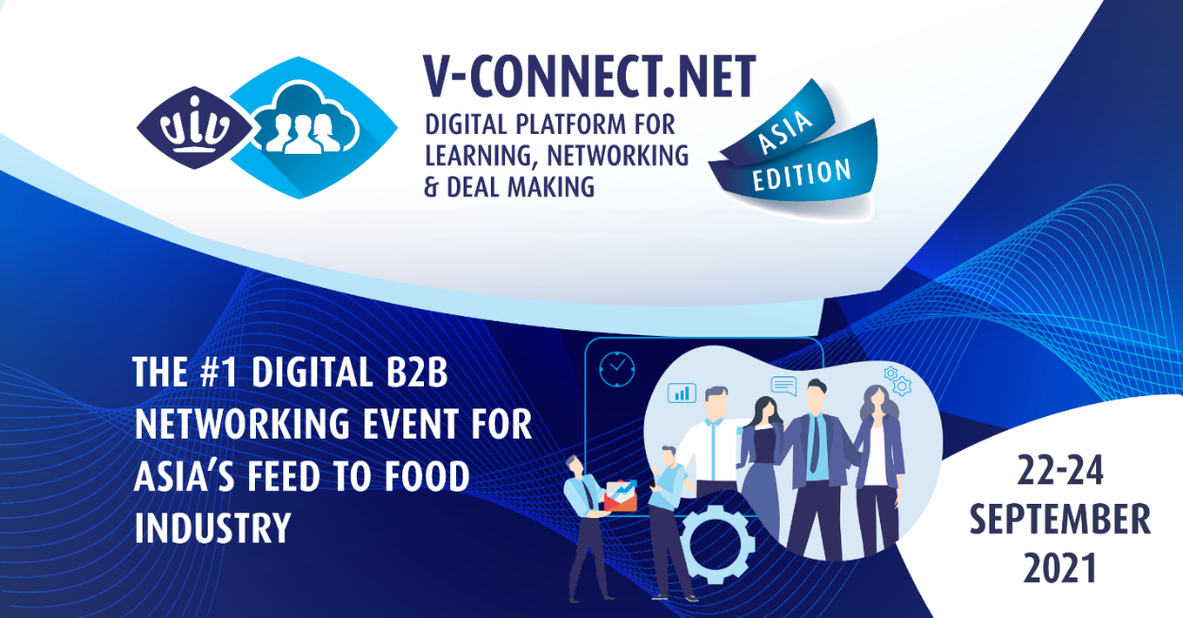

End of Press Release
Notes for Press ------------------------------------------------------------------------------------------------------------------

Contacts:
- Ms. Elena Geremia (VIV worldwide Senior Marcom Manager) | elena@vnueurope.com
- Mrs. Saengtip Techapatiphandee (VIV Asia & V-Connect Assistant Marcom Manager ) | saengtip@vnuasiapacific.com

VIV worldwide is the business network linking professionals from feed to food, offering boundless opportunities to the animal protein supply chain players. VIV worldwide developed with dedication a network through 40 years of experience and interactions with the industry, becoming today the leading platform in and for some of the most promising markets of the world.
The V-Connect platform is the digital result of the conversion of VIV worldwide in-person B2B networking events into an online format to suit the current business landscape. ‘V’ stands for VIV and ‘Connect’ reflects the commitment to facilitating business networking regardless of location or current restrictions. The platform provides a progressive web-based, smartphone-supported online ecosystem. V-Connect offers businesses a reliable, responsive and highly actionable platform. .

